|  |
| --- |
| *CometBites* |
| **High-level Architecture** |
| **SE 6387 Advanced Software Engineering Project**  **R.Z. Wenkstern**    ***10/29/2016*** |

|  |
| --- |
| **Group *CometBites*** |
| **Ronaldo Goncalves Junior**  **rxp152830** |
| **Twinkle Sharma**  **txs151730** |
| **Keerthi Santhalingam**  **kxs142830** |
| **Ramakrishnan Sathyavageeswaran**  **rxs142530** |

# 

# Revision History

|  |  |  |  |
| --- | --- | --- | --- |
| **Version** | **Date** | **Description** | **Authors** |
| 0.2 | 10/19/16 | Initial draft | Ronaldo |
| 1.0 | 10/27/16 | Completed version 1 | Ronaldo |

# **1. Logical View**



**Figure 1: logical view - tiered architecture.**

# 2. Composite Structures

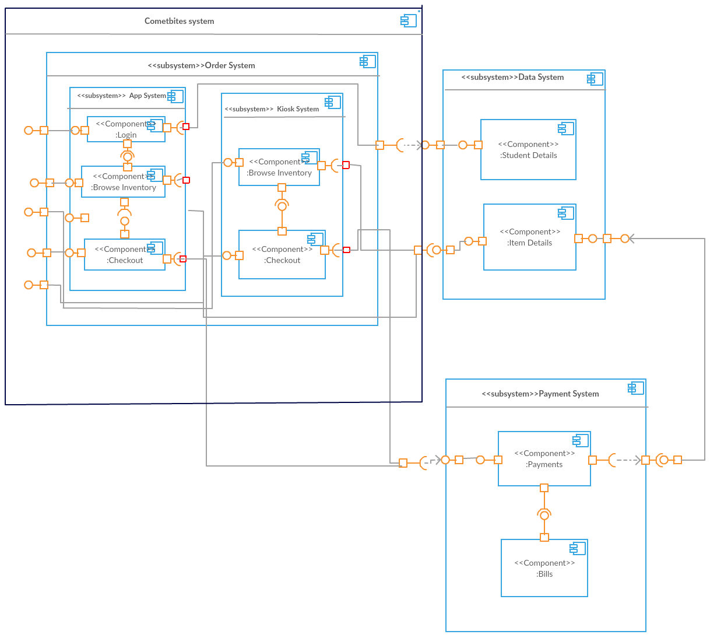

**Figure 2: CometBites composite structures diagram.**